Greenhouse Monitoring and Control System using IOT Project

A green house is where plants such as flowers and vegetables are grown. Greenhouses warmup during the day when sun-rays penetrates through it, which heats the plant, soil and structure. Green houses help to protect crops from many diseases, particularly those that are soil borne and splash onto plants in the rain. Greenhouse effect is a natural phenomenon and beneficial to human being. Numerous farmers fail to get good profits from the greenhouse crops for the reason that they can’t manage two essential factors, which determines plant growth as well as productivity. Green house temperature should not go below a certain degree, High humidity can result to crop transpiration, condensation of water vapour on various greenhouse surfaces, and water evaporation from the humid soil. To overcome such challenges, this greenhouse monitoring and control system comes to rescue. This project demonstrates the design and implementation of a various sensors for greenhouse environment monitoring and controlling. This greenhouse control system is powered by Atmega328 microcontroller it consists of temperature sensor, light sensor, soil moisture sensor, LDR sensor, LCD display module, 12v DC fan, Bulb and pump. Temperature sensor, senses the level of temperature., if it goes high DC fans gets on and when the temperature goes low the fan gets off. Soil moisture sensor, senses the water level as the level decreases the pumps gets on. In the absence of light, the LDR sensor senses and the bulb starts glowing. By this way it will become easy to monitor and control the system.

Block Diagram :

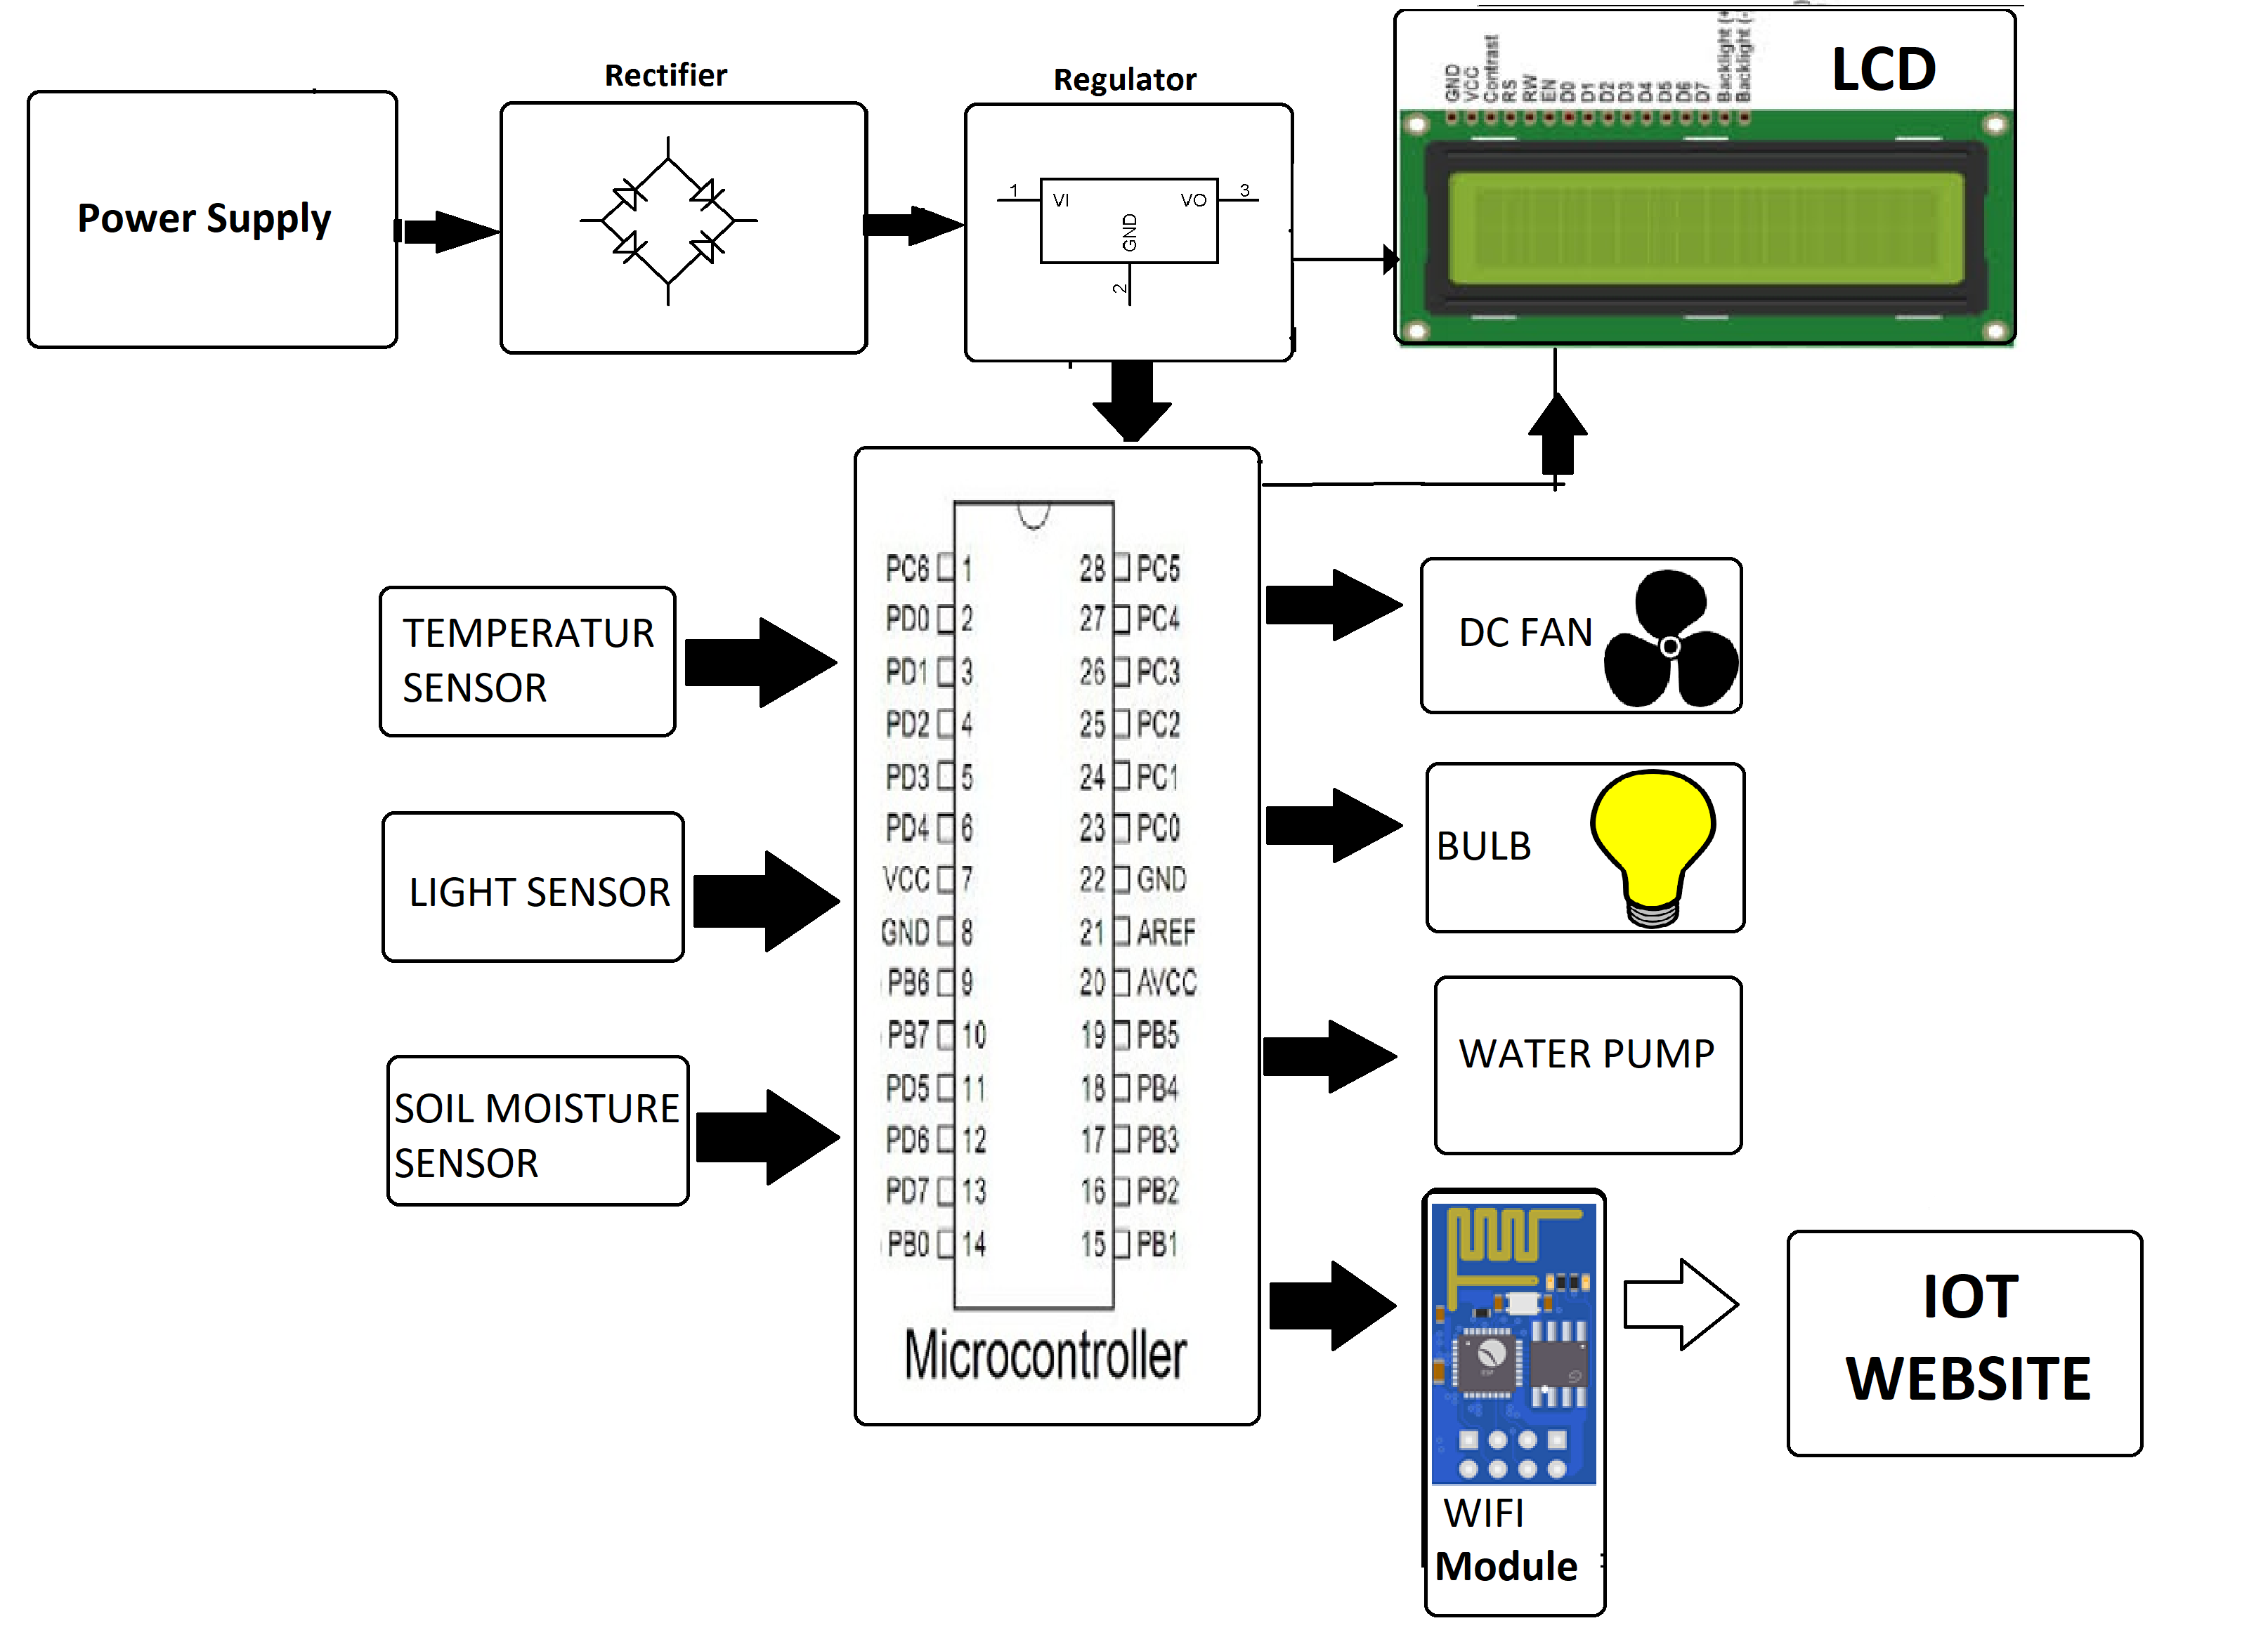

Hardware Specifications :
- At mega Controller

- WIFI

- Moisture Sensor

- Light Sensor

- Temperature Sensor

- LCD

- DC FAN

- Bulb holder

- AC Pump

- Crystal Oscillator

- Resistors

- Capacitors

- Transistors

- Cables and Connectors

- Diodes

- PCB and Breadboards

- LED

- Transformer/Adapter

- Push Buttons

- Switch

- IC

- IC Sockets

